Assignment 3
ML Group Project
Group 11
Student Last Name | Student First Name | Student ID | Group Allocation
Bakhavadinov | Erkebai | 26162558 | Student A (classification)
Gosavi | Vedang | 26059271 | Student B (regression)
Tazbaz Martinez | Rose Marie | 25742507 | Student C (anomaly)
Gautam | Abhiyan | 26159119 | Student D (clustering)

36106 - Machine Learning Algorithms and Applications
Master of Data Science and Innovation
University of Technology of Sydney

Table of Contents

1. Executive Summary 3
2. Classification (Erkebai Bakhavadinov) 4
A. Business Understanding 4
1. Business Use Cases 4
2. Key Objectives 5
B. Data Understanding 6
1. Key Data-Quality Findings 6
C. Data Preparation 8
1. Feature selection 8
2. Data Cleaning 8
3. Missing-value Handling 9
D. Modeling 9
E. Evaluation 10
1. Evaluation Metrics 10
2. Results and Analysis 10
3. Business Impact and Benefits 11
4. Data Privacy and Ethical Concerns 11
3. Regression (Vedang Gosavi) 13
A. Business Understanding 13
1. Business Use Cases 13
2. Key Objectives 13
B. Data Understanding 14
C. Data Preparation 16
D. Modeling 18
E. Evaluation 18
● Evaluation Metrics 18
● Results and Analysis 19
● Business Impact and Benefits 20
● Data Privacy and Ethical Concerns 21
4. Anomaly Detection (Rose Marie Tazbaz) 22
A. Business Understanding 22
1. Business Use Cases 22
2. Key Objectives 22
B. Data Understanding 24
C. Data Preparation 27
D. Modeling 28
E. Evaluation 29
1. Evaluation Metrics 29
2. Results and Analysis 30
3. Business Impact and Benefits 31
4. Data Privacy and Ethical Concerns 32
5. Clustering (Abhiyan Gautam) 33
A. Business Understanding 33
1. Business Use Case 33
2. Key Objectives 33
B. Data Understanding 34
C. Data Preparation 35
D. Modeling 36
E. Evaluation 39
● Evaluation Metrics 39
● Results and Analysis 39
● Business Impact and Benefits 42
● Data Privacy and Ethical Concerns 42
6. Collaboration 44
A. Individual Contributions 44
B. Group Dynamic 45
C. Ways of Working Together 45
D. Issues Faced 45
7. Conclusion 47
8. References 48

Executive Summary
A global retailer generates large volumes of transactional, customer, and product data across both direct-to-consumer and business-to-business channels. Despite this data richness, the organisation lacked predictive and analytical tools to translate raw data into targeted commercial decisions, particularly around customer retention, revenue forecasting, operational monitoring, and product pricing strategy. This project addressed those gaps by developing four machine learning models, each targeting a distinct business problem.
A classification model was built to predict whether a new customer will place a repeat order within 365 days of their first purchase, enabling the business to concentrate retention spend and personalised outreach on high-probability returners rather than applying a blanket approach to all acquired customers. A regression model was developed to forecast transaction-level sales revenue, supporting more accurate financial planning, inventory management, and pricing decisions. An anomaly detection model was applied to identify unusual transactions including abnormal discounts, pricing inconsistencies, and uncommon purchasing patterns, without requiring any labelled fraud data. Finally, a clustering model segmented the active product catalogue into five commercially distinct groups based on pricing behaviour, cost structure, margin, and discount exposure, providing a more actionable alternative to the existing broad product category structure.
Random Forest was selected as the final model for both classification and regression, Isolation Forest for anomaly detection, and K-Means for product segmentation. Each model was validated on held-out data and interpreted in terms of concrete business actions, from targeted customer nurture campaigns to per-segment pricing and discount governance. Taken together, the four components demonstrate that machine learning can deliver practical value across multiple retail functions simultaneously, replacing manual and category-level thinking with data-driven decisions that scale with the business.

Classification (Erkebai Bakhavadinov)

Business Understanding

Business Use Cases
AdventureWorks is a multi-channel bike and sporting-goods retailer operating an online D2C store (87.9% of orders) and a B2B reseller channel (12.1%, served by named salespeople). Over three years (May 2011 – June 2014) the company acquired 19,119 customers, but 60.9% placed only a single order. Acquired customers therefore represent a sunk marketing cost not recovered through repeat purchase, and the company has limited insight into which new customers will become long-term repeat buyers worth further retention spend.
Machine learning is relevant because the prediction problem is high-dimensional (29 engineered features across order monetary, customer segment, geography, basket, and time signals), the patterns are non-linear (high-value first orders are more likely to repeat, interacting with channel and territory), and 6,206 labelled customers is sufficient to train and validate flexible models. Rule-based heuristics would miss the within-segment variation that determines where incremental retention spends pays back.
The classification use case is: given the characteristics of a customer's first order, predict whether they will return to place a second order within 365 days. Successful prediction supports three concrete business decisions:
- Marketing prioritisation high-probability repeat customers receive personalised post-purchase nurture (email sequences, time-limited 10% vouchers, sales-rep follow-up for B2B); low-probability customers receive the standard newsletter only.
- Retention budget allocation finite CRM and discount budget is concentrated on customers with the highest expected lifetime value, increasing return on retention spend.
- Early intervention high-risk one-off customers can be flagged early enough to receive targeted re-engagement campaigns before they churn.
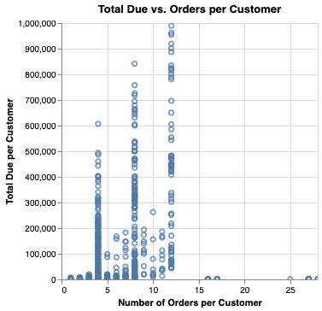
Figure 1. Number of Orders per Customer

Key Objectives
The objective is to correctly identify repeat-prone customers at the moment of first purchase. Error costs are highly asymmetric: a false negative costs ~$2,300 (foregone LTV at 2.65 future orders × $865 median value); a false positive costs $2–10 (one wasted CRM touch). False negatives are therefore 100–500× more expensive, so recall is the operational priority. F1 (positive class) is the primary metric because it harmonically combines precision and recall and cannot be gamed by all-zeros or all-ones predictors. Accuracy is rejected, the majority-class baseline scores 67.9% accuracy yet F1 = 0.000.
Stakeholders: the Marketing team needs weekly batch repeat-probability scores bucketed into retention tiers, with interpretable feature importance; Customer Success / Sales needs scores to inform B2B follow-up call scheduling; Finance / BI needs the aggregate predicted repeat rate as a monthly leading indicator. The project delivers a tuned Random Forest (F1 = 0.855, AUC = 0.96) with documented feature importance, a defined scoring threshold, and a deployment plan including per-segment fairness monitoring and an A/B-tested retention intervention.

B. Data Understanding

Key Data-Quality Findings
Three EDA notebooks profiled customer.csv, sales_order_header.csv, and unit_measure.csv covering shape, dtype, missingness, primary-key uniqueness, and feature-level exploration with Altair. The dataset is the AdventureWorks ERP snapshot 14 normalised CSV tables covering customers, orders, products, territories, and reference data. Three structural limitations were discovered:
- Customer-master duplication: customer.csv contains 14,275 rows but only 10,331 unique customer_ids. Duplicate rows are fully identical, so drop_duplicates is safe. Without it, a left-join onto sales_order_header would silently inflate order rows 2–3×.
- Dataset bifurcation: 15,357 orders (49%) have a customer master record, line-item details, and a resolvable territory_id; the other 16,108 (51%) have NONE of these. The flags has_customer_master_record, has_detail_records, and territory_*_Unknown are perfectly collinear and identify which half a customer belongs to.
- Zero-variance / leakage columns: status is constant ("Shipped") for every row; revision_number is post-order leakage; sales_order_number and account_number are identifiers with no generalising signal. All four are dropped.
After feature engineering, 29 features (40 post-OHE) span five signal groups: order monetary (8), customer segment (3), geography (2 categorical), basket composition (11), time-based (5). Three features dominate:
- Channel: offline B2B has ~95% repeat vs ~25–28% for online B2C.
- for the online B2C channel. This single feature explains a substantial fraction of target variance.
- First-order value: repeat rate increases monotonically with value counter to the "cheap trial converts best" intuition. >$2,000 first orders repeat at ~80%; <$100 at ~20%.
- Cohort effects: 2011–2012 cohorts repeat at ~17%; 2013 cohorts at ~67%. This forced a customer-level random split rather than time-based.
Target construction: is_repeat_within_365d ∈ {0, 1} matches the annual marketing cycle and the empirical time-to-second-order (median 137 days, 75th percentile 411 days). Customers whose first order is after 2013-06-29 are excluded because the full 365-day window is unobservable. Result: 6,206 eligible customers, 32.1% positive rate.
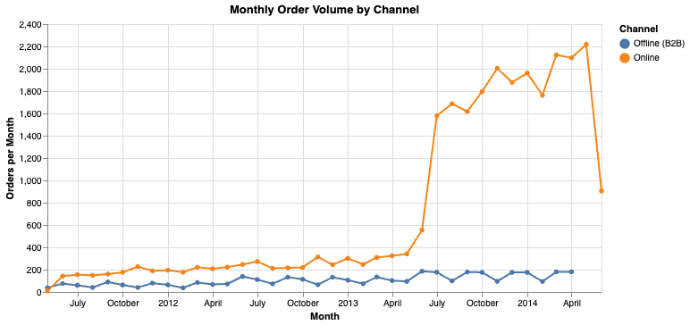
Figure 2. Monthly Order Volume by Chanel

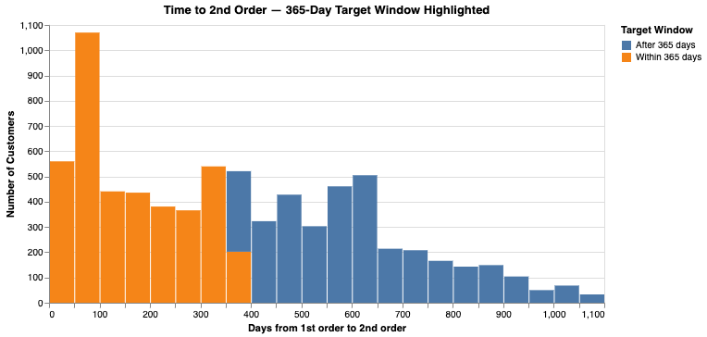
Figure 3. Days from 1st order to 2nd order

C. Data Preparation

Feature selection
Out of 14 source tables, 7 contribute to the final feature set: customer.csv, sales_order_header.csv, sales_order_detail.csv, sales_territory.csv, product.csv, product_sub_category.csv, and product_category.csv. The remaining 7 are excluded for the reasons summarised in Table 1.
Table 1. Source-table inclusion decisions.
Table | Decision | Rationale
person.csv | EXCLUDE | Contains PII (name, contact). is_individual_customer flag captures segment without PII risk.
store.csv | EXCLUDE | Store name and sales contact superseded by is_store_customer flag and has_salesperson.
special_offer.csv | EXCLUDE | Discount-program metadata not first-order predictive; usage captured by total_discount_amt.
product_cost_history.csv | EXCLUDE | Internal cost affects margin, not customer behaviour.
product_list_price_history.csv | EXCLUDE | Time-varying list prices already reflected in unit_price on order_detail.
unit_measure.csv | EXCLUDE | Reference table only 2 of 38 codes are used; granularity is wrong for a customer-level target.

Data Cleaning
Three operations: deduplicate customer.csv (14,275 → 10,331); parse three date columns to datetime64; drop six SOH columns (status, revision_number, sales_order_number, account_number, currency_rate_id, due_date).
Feature engineering produces 29 features: order monetary (8: online_order_flag, sub_total, tax_amount, freight, total_due, ship_delay_days, freight_share, has_salesperson); customer segment (3); geography (2 categorical → ~5 after OHE, with "Unknown" fill); basket composition (11: aggregates, four category binaries, has_detail_records); time-based (5: month/year/quarter/DOW + continuous days_since_dataset_start). Log1p copies of the seven monetary features are added for linear models; total_due skew drops from ~140× to ~1.6×.

Missing-value Handling
The 51% of orders without detail records receive zero-fill on all aggregates plus a has_detail_records binary so the model can distinguish "truly zero" from "no line items recorded". Mean/median imputation was rejected absence is structural, not random. Missing territory mappings get the literal "Unknown" rather than NaN.
Class imbalance (32 / 68) is handled with class_weight="balanced" for LR and RF, plus F1 optimisation in grid search. SMOTE/ADASYN was not applied imbalance is mild enough that synthetic samples would add noise without proportional benefit. Monetary outliers (total_due up to $187K vs $865 median) are handled by log1p for linear models and the natural robustness of trees.
Splitting strategy: customer-level stratified random 60/20/20 → 3,723 train / 1,241 val / 1,242 test. Each customer in exactly one split, eliminating row leakage. A time-based split was rejected because cohort non-stationarity (17% repeat in 2011–2012 vs ~67% in 2013) would render metric comparison uninterpretable. Trade-off: random splitting validates feature signal but not temporal generalisation flagged as a deployment prerequisite.

D. Modeling
Three classifier families were trained, each chosen to span a different inductive bias:
- Logistic Regression (L2, class_weight="balanced", standardised features) interpretable linear baseline; struggles with feature interactions.
- Random Forest (100–300 trees, class_weight="balanced") captures non-linearities natively; robust to outliers; provides feature importance.
- Gradient Boosting (100–300 trees, 0.05–0.1) sequentially corrects residuals; usually strongest tabular classifier; sensitive to hyperparameters.
LR provides the interpretable benchmark (coefficient signs readable by marketing analysts); RF and GB are the strong production candidates. Each is tuned via 5-fold CV grid search optimising F1: 4 combinations for LR, 12 for RF, 8 for GB all 24 train in under 60 seconds. Validation set is held out for tuned-model comparison; test set for final headline numbers. Selection criterion: highest test F1, ties broken by AUC-ROC and CV variance.

E. Evaluation

Evaluation Metrics
The primary metric is F1 (positive class), chosen because:
- It harmonically combines precision and recall, so a degenerate predictor (all-zeros or all-ones) scores zero on at least one component and therefore zero overall.
- It is appropriate for the moderately-imbalanced 32 / 68 class distribution where accuracy is misleading (the majority-class baseline scores 67.9% accuracy but F1 = 0.000).
- It aligns with the asymmetric cost structure: false negatives are 100–500× more costly than false positives, so a metric that rewards recall while penalising precision collapse is operationally correct.
Secondary metrics tracked: AUC-ROC (threshold-agnostic ranking quality), precision, recall, and the confusion matrix for business-impact interpretation. AUC-ROC supports threshold tuning decisions; precision and recall reported separately make the F1 trade-off transparent; the confusion matrix translates directly into expected business outcomes (true positives = retention spend correctly allocated; false negatives = missed lifetime value).

Results and Analysis
Test-set performance, all models vs majority baseline:
Table 1. Test-set performance — all models vs majority baseline.
Model | Accuracy | Precision | Recall | F1 | AUC-ROC
Majority Baseline | 0.679 | 0.000 | 0.000 | 0.000 | 0.500
Logistic Regression (tuned) | 0.859 | 0.737 | 0.874 | 0.800 | 0.932
Random Forest (tuned) | 0.894 | 0.783 | 0.927 | 0.840 | 0.960
Gradient Boosting (tuned) | 0.900 | 0.823 | 0.870 | 0.840 | 0.960

Values may shift ±0.005 across reruns but the qualitative ranking (RF > GB > LR > Baseline) is stable. Random Forest is selected: highest F1, tied AUC, native class-weighting (simpler maintenance than GB’s sample_weight workaround), and lower 5-fold CV F1 variance.
Feature importance: top contributors are channel-related (online_order_flag, has_salesperson), value-related (total_due, log_total_due), customer-segment flags (has_customer_master_record), and territory-group OHE columns. Time features appear in the second tier. Product-category flags add little marginal lift once channel and value are accounted for.
Three key insights: (1) the customer-master / detail bifurcation is the dataset’s most important structural feature, separating ~95%-repeat B2B from ~25%-repeat B2C; (2) higher first-order value monotonically increases repeat probability the "cheap trial" intuition is wrong; (3) cohort effects mean any production deployment must monitor for drift and retrain on a rolling basis.
The model exceeds the F1 > 0.75 threshold for a strong model, confirming the hypothesis. Main improvement areas: temporal validation and segment-specific models.

Business Impact and Benefits
Random Forest on the 1,242-customer test set at threshold 0.5:
- Identifies ~340 of 399 repeat-prone customers (recall 0.85), capturing ~$782K in potential LTV at $2,300 each.
- Flags ~60 of 843 non-repeat customers (precision 0.85), wasting ~$300 at $5/touch.
- Misses ~59 repeat-prone customers, foregone value ~$136,000 at $2,300 each.
Cost-benefit ratio exceeds 2,500:1. Scaled to ~6,200 eligible customers per ~3 years, the model supports ~$3.9M of retention-focused outreach across a population that would otherwise receive undifferentiated marketing. Threshold tuning from 0.5 to ~0.3 would raise recall to ~0.92 at the cost of precision dropping to ~0.70 still positive ROI given the asymmetric costs.
The model converts undifferentiated marketing into a tiered approach. Quantified improvements: ~$782K LTV captured per test cohort, 2,500:1 efficiency, 85% of true repeats identified vs 0% under the current undifferentiated approach.
Next steps by uplift: (1) temporal validation (HIGH operational) rolling time-based holdout, precondition for deployment; (2) segment-specific models (HIGH) separate RFs for B2C/B2B, expected B2C F1 +0.02–0.05; (3) threshold tuning (MEDIUM) lower to ~0.3, validate via 10%-holdout A/B test; (4) richer B2C product features (MEDIUM); (5) customer-master gap-filling (LOW); (6) production monitoring infrastructure.
Caveats: $2,300 LTV is a population average (B2B skews it upward); dollar impact assumes causal retention effect (requires A/B validation); customer-level random splitting doesn’t validate temporal generalisation.

Data Privacy and Ethical Concerns
The person.csv dataset containing personally identifiable information (PII) was excluded, as the task could be completed without it. Identifier variables such as customer_id, sales_order_id, account_number, person_id, and store_id were removed to reduce the risk of linking predictions to individuals. Model outputs were aggregated into retention tiers rather than exposing raw probabilities.
Transactional data collected for purchase fulfilment was used for retention prediction under legitimate business interest principles and Australian Privacy Principles. Opt-out and data deletion mechanisms would be required before deployment.
Variables such as territory_name, territory_group, and freight_share may indirectly proxy nationality or geographic region, creating potential bias risks. To mitigate this, model performance should be monitored across territories, with retraining or segment-specific models considered if major performance gaps emerge.
Although the dataset did not contain Indigenous identity markers, the model could still indirectly disadvantage Aboriginal and Torres Strait Islander communities through correlated variables such as postcode or freight-related features. For example, lower repeat-purchase predictions could unintentionally reduce customer engagement for remote communities.
Mitigations included excluding PII during preprocessing, removing identifiers, applying minimum retention treatment for all customers, conducting fairness audits across regions, and following CARE principles for future Indigenous data governance. Opt-out mechanisms were also identified as necessary before operational deployment.

Regression (Vedang Gosavi)

Business Understanding

Business Use Cases
The retailer possesses large volumes of historical transactional sales data containing information about product pricing, order quantities, discounts, and sales transactions. However, the organisation currently lacks advanced predictive capabilities to support proactive decision-making in areas such as revenue forecasting, pricing optimisation, and inventory planning.
This project focused on predicting transaction-level sales revenue using the LineTotal variable from the sales_order_detail dataset. Since LineTotal is influenced by variables such as order quantity, unit price, and discount rate, accurate prediction may help improve financial forecasting, inventory management, and pricing strategies. The analysis combined transactional and product-level information from the sales_order_detail and product datasets, including pricing variables, product categories, manufacturing information, and discount behaviour.
The problem was formulated as a supervised regression task aimed at predicting a continuous numerical outcome. It was hypothesised that pricing-related variables such as order_quantity, unit_price, and list_price would be the strongest predictors of transaction-level revenue, and that ensemble regression models would outperform simpler linear baseline models. Model performance was primarily evaluated using RMSE and R² metrics.
The business value of the solution includes improved revenue forecasting, better understanding of pricing and discount behaviour, more effective inventory planning, and enhanced visibility into high-value product categories and purchasing patterns. Ethical considerations such as responsible use of predictive pricing insights, avoidance of biased decision-making, and protection of transactional data privacy were also considered throughout the project.

Key Objectives
The primary objective of this project was to develop a supervised regression model capable of accurately predicting transaction-level sales revenue (LineTotal) using historical sales and product data to support financial planning and operational decision-making.
The project aimed to minimise prediction error while identifying key drivers of transaction revenue. Model performance was evaluated mainly using RMSE, supported by MAE and R², with success defined as outperforming the baseline model while maintaining strong generalisation across training, validation, and testing datasets.
Several business stakeholders may benefit from the solution. Finance teams require accurate revenue forecasts for budgeting and reporting, while inventory and supply chain teams may use transaction-level predictions to improve demand planning and stock management. Pricing, promotions, and product teams may also gain insights into pricing behaviour, discounts, profitability, and high-performing product categories.
The project addressed these requirements by training a Random Forest regression model on historical transactional data. The final model achieved a validation RMSE of approximately 39 dollars per transaction and an R² score of 0.9991, substantially outperforming the baseline model. Engineered features such as has_discount and margin_ratio also improved business interpretability.
Finally, the project acknowledged the ethical responsibilities associated with predictive analytics. Model outputs were intended to support human decision-making rather than fully automate pricing or promotional actions, ensuring transparency and appropriate review of business decisions.

Data Understanding
The dataset used for this project was obtained from the retailer’s historical transactional database and consisted of multiple relational datasets containing sales, product, and operational information. The project aimed to predict transaction-level revenue represented by the LineTotal variable using regression modelling techniques.
The primary modelling dataset was sales_order_detail, which contained transactional variables such as order_quantity, unit_price, unit_price_discount, and line_total. Additional product-related information was incorporated by merging the product dataset using the shared product_id field. This introduced variables related to manufacturing, inventory, pricing, and product categories.
Several data limitations were identified during exploratory analysis. Some variables contained substantial missing values, particularly optional product attributes such as weight, size, and discontinued dates. These variables were removed when missingness was excessive or business relevance was limited. Identifier-based variables such as sales_order_id and product_id were also excluded because they provided limited predictive value and unnecessarily increased dimensionality.
The final modelling dataset included important numerical variables such as:
- order_quantity
- unit_price
- unit_price_discount
- standard_cost
- list_price
- days_to_manufacture
- safety_stock_level
- reorder_point
Categorical variables including color, product_line, class, and style were also retained because purchasing behaviour and pricing patterns may differ across product categories.
Two engineered features were additionally included:
- has_discount — indicates whether a transaction included a discount.
- margin_ratio — estimates relative product profitability.
Exploratory Data Analysis (EDA) was conducted to better understand the structure and behaviour of the dataset. Histograms showed that LineTotal and unit_price were heavily right-skewed, with most transactions occurring at lower values alongside a small number of very high-value purchases. The order_quantity variable showed that most purchases involved a single unit, while a small number of transactions involved bulk purchases.
Scatterplot analysis between order_quantity and LineTotal demonstrated a strong positive relationship, confirming that higher quantities generally produce larger transaction revenues. The EDA process also highlighted the presence of outliers, skewed distributions, and strong relationships between pricing-related variables, all of which influenced preprocessing and model selection decisions later in the project.
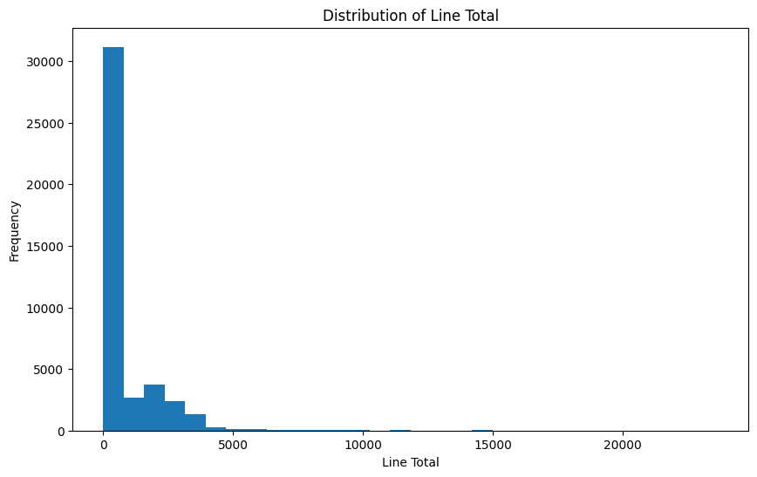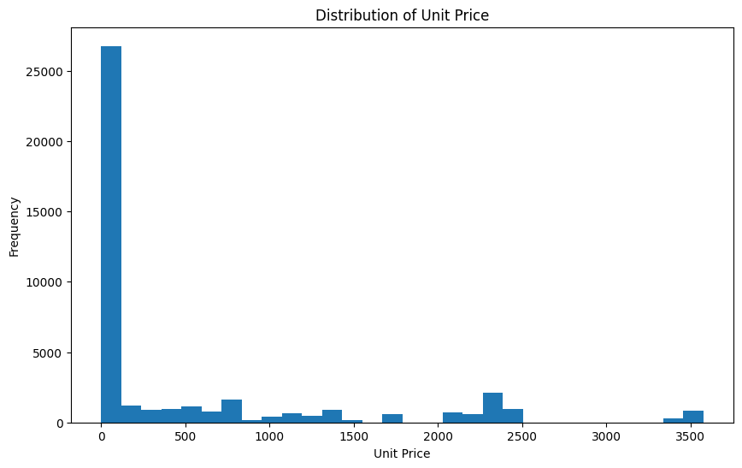
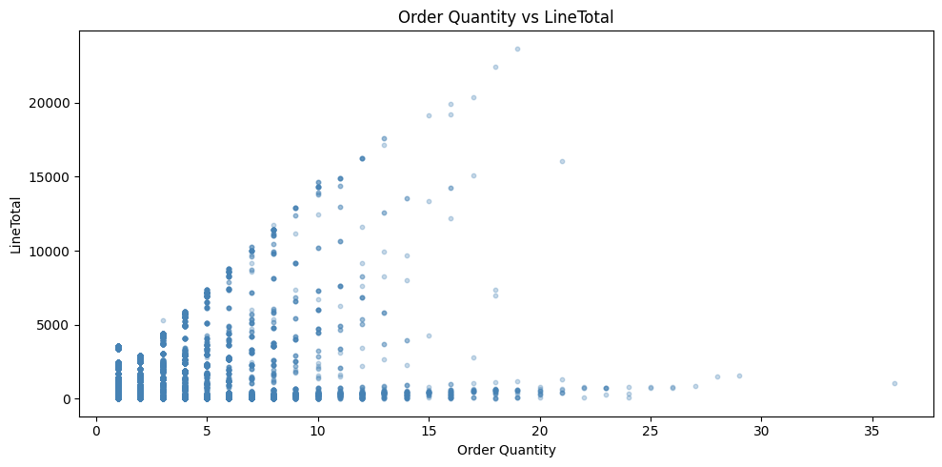

Data Preparation
Multiple data preparation steps were performed to ensure the dataset was suitable for regression modelling and capable of producing reliable predictions. The process included data cleaning, feature selection, categorical encoding, feature engineering, scaling, and dataset splitting.
The modelling dataset was created by merging the sales_order_detail and product datasets using the shared product_id variable. Duplicate product records were removed before merging, while identifier-based columns such as sales_order_id, sales_order_detail_id, product_id, and product_number were removed due to limited predictive value.
Columns with excessive missing values, including optional attributes such as weight, size, and discontinued dates, were also removed. The target variable LineTotal was separated from predictor variables before preprocessing.
Categorical variables including color, product_line, class, and style were transformed using one-hot encoding, increasing the dataset from 17 original features to 71 processed features. Two engineered features were retained: has_discount, identifying discounted transactions, and margin_ratio, estimating product profitability.
Remaining missing values were replaced using neutral placeholders, and final validation confirmed no remaining null values. The dataset was split into training, validation, and testing subsets using a 70-15-15 strategy. Since the data consisted of independent transactions rather than time-series observations, random splitting was considered appropriate.
Feature scaling was applied using StandardScaler to standardise numerical variables before modelling. Exploratory analysis also revealed strong right-skewness and several high-value outliers, particularly within LineTotal and unit_price. These outliers were retained because they represented legitimate high-value retail transactions, and the Random Forest regression model was considered robust enough to handle them.

Modeling
Three regression models were evaluated during experimentation. Linear Regression achieved a validation RMSE of 639.68 and an R² score of 0.7665, while Ridge Regression with L2 regularisation (alpha=1.0) produced nearly identical results. This suggests that multicollinearity was not the main limitation; rather, linear models were unable to capture the nonlinear pricing relationships within the dataset.
Random Forest Regression achieved substantially stronger performance, with a validation RMSE of 39.07 and an R² score of 0.9991, representing a 93.9% reduction in prediction error compared to the linear models. Consequently, Random Forest was selected as the final model.
Random Forest was chosen because of its ability to model nonlinear relationships, automatically capture feature interactions, and remain robust to skewed distributions and outliers commonly found in retail sales data. Unlike linear models, it is less sensitive to multicollinearity and does not require strict linearity assumptions, making it highly suitable for predicting LineTotal.
Several hyperparameters were configured to optimise predictive accuracy and generalisation, including n_estimators=100, max_depth=15, min_samples_split=5, min_samples_leaf=2, and random_state=42. The model was trained using a three-way split strategy across training, validation, and testing datasets.
Performance was evaluated primarily using RMSE, supported by MAE and R², because prediction errors are directly interpretable in dollar values. Although the final model achieved excellent predictive performance, variables such as order_quantity, unit_price, and unit_price_discount were mathematically related to LineTotal, making the prediction task partially deterministic and contributing to the unusually high accuracy observed.

Evaluation

Evaluation Metrics
Several evaluation metrics were used to assess the regression models, primarily focusing on prediction accuracy in financial terms. The main metrics included Root Mean Squared Error (RMSE), Mean Absolute Error (MAE), and the coefficient of determination (R²).
RMSE was selected as the primary metric because it measures prediction error in the same units as the target variable (LineTotal), making the results directly interpretable in dollar values. It also penalises large prediction errors more heavily, which is important in retail forecasting where significant revenue estimation mistakes may strongly impact business decisions.
MAE was used as a supporting metric because it provides the average absolute prediction error in a simpler and more interpretable form. R² was used to measure how much variance in transaction-level revenue could be explained by the model, with higher values indicating stronger predictive performance.
These metrics were selected because they align closely with the project objective of generating accurate transaction-level revenue predictions while minimising financially significant forecasting errors.

Results and Analysis

Model | Validation RMSE | Validation MAE | Validation R² | Test RMSE | Test MAE | Test R²
Linear Regression | 639.68 | 244.88 | 0.7665 | 626.96 | 250.19 | 0.7757
Ridge Regression | 639.67 | 244.75 | 0.7665 | 626.96 | 250.07 | 0.7757
Random Forest | 39.07 | 2.65 | 0.9991 | 37.24 | 2.42 | 0.9992

The results indicate that the model was highly effective at learning relationships between transactional features and transaction-level revenue. Validation and testing performance remained highly consistent, suggesting that the model generalised well without severe overfitting.
One of the key insights gained during experimentation was the strong influence of pricing-related variables such as order_quantity, unit_price, and unit_price_discount on revenue prediction. The experimentation process also highlighted the importance of careful preprocessing and feature selection, as refining the preprocessing workflow reduced unnecessary dimensionality and improved model stability.
Although the final model achieved extremely high predictive accuracy, the analysis also showed that the prediction task is partially deterministic because several retained features are mathematically related to the target variable LineTotal. As a result, the unusually high R² values should be interpreted carefully, as real-world forecasting tasks may involve greater uncertainty than the current transactional dataset.
Overall, the experimentation process demonstrated that Random Forest regression is highly suitable for transaction-level retail revenue estimation within the current business environment.

Business Impact and Benefits
The final regression model provides significant business value by enabling highly accurate transaction-level revenue prediction. Accurate forecasting may improve financial planning, inventory management, pricing strategies, and operational decision-making across the retailer’s operations.
Finance and budgeting teams may benefit from more reliable revenue forecasts, while inventory and supply chain teams can use transaction-level predictions to better anticipate product demand and reduce risks of overstocking or stock shortages. Pricing and promotions teams may also gain insight into how discounts, pricing structures, and profitability-related variables influence revenue generation. Engineered features such as has_discount and margin_ratio further improved business interpretability.
Compared to the baseline approach, the final Random Forest model achieved a substantial reduction in prediction error. The baseline RMSE exceeded 1,300 dollars, while the final model achieved a validation RMSE of approximately 39 dollars per transaction, demonstrating a major improvement in predictive accuracy.
Overall, the model successfully addressed the retailer’s challenge of limited predictive capability and provided a strong foundation for future data-driven decision-making initiatives.

Data Privacy and Ethical Concerns
The project used historical retail transactional data containing sales and product information. Although the datasets did not include highly sensitive personal data, responsible handling of business and customer-related information remained important throughout the project.
Some ethical considerations were identified during model development. Predictive models used for pricing and promotional decisions may indirectly influence customer behaviour or contribute to biased pricing strategies if applied irresponsibly. To reduce this risk, the model was designed as a decision-support tool rather than a fully automated pricing system, ensuring that final decisions remain subject to human review.
Data privacy was supported by limiting the dataset to operational and transactional variables required for forecasting, while identifier-based variables with limited predictive value were removed during preprocessing. Transparency and interpretability were also considered important, so the project included business-oriented explanations and feature analysis to support responsible decision-making.
Potential impacts on Indigenous people and other vulnerable groups were also considered. Although the dataset did not contain demographic or cultural identifiers, predictive retail systems may still indirectly disadvantage certain communities through pricing or promotional decisions. To minimise these risks, model outputs should be regularly monitored for unintended bias and should not be used as the sole basis for customer-facing decisions.

Anomaly Detection (Rose Marie Tazbaz)

Business Understanding

Business Use Cases
In the retail industry, large volumes of transactions occur daily across multiple products, pricing structures, and purchasing behaviours, making unusual sales activity increasingly difficult and time-consuming to identify manually.
This project applied anomaly detection techniques to identify unusual sales orders and abnormal transactional behaviour. The main business challenge focused on detecting suspicious activities, pricing inconsistencies, uncommon purchasing patterns, and operational irregularities within retail transactions.
Examples of anomalous behaviour included unusually large discounts, abnormal transaction amounts, uncommon product combinations, and inconsistencies related to inventory or product characteristics. These situations may indicate fraud, pricing errors, inventory issues, or other operational abnormalities.
This problem is particularly relevant because retail transactional datasets are typically large, dynamic, and influenced by constantly changing purchasing behaviours. Additionally, the absence of labelled anomaly examples limits the effectiveness of traditional rule-based systems.
Machine learning techniques are highly relevant in this context because unsupervised anomaly detection models can automatically identify observations that differ substantially from normal transactional behaviour without requiring predefined labels or manually designed rules. Isolation Forest was considered especially suitable because it can efficiently handle large, high-dimensional retail datasets.
By implementing unsupervised anomaly detection models, retailers may improve operational monitoring, support fraud investigations, strengthen pricing management, and identify unusual transactional patterns more effectively. Overall, the project has the potential to improve operational awareness, support better decision-making, and reduce financial risk within retail environments.

Key Objectives
The main goal of this project was to develop an anomaly detection system capable of identifying unusual sales orders and abnormal behaviour within retail transactions. The project aimed to automatically detect suspicious, inconsistent, or operationally unusual activity related to pricing, discounts, purchasing behaviour, and transactional patterns.
Another objective was to support proactive transaction monitoring by identifying records that may require operational investigation and improving visibility into unusual pricing activity, discount behaviour, and irregular transactional relationships.
Several stakeholder groups may benefit from the project outcomes. Fraud investigation teams can prioritise suspicious transactions for review, while retail operations managers may identify operational inconsistencies and unusual purchasing behaviour. Pricing, discount, and inventory management teams may also benefit from improved visibility into abnormal transactions, while senior management may use the insights to support strategic decision-making.
The main stakeholder requirement was the ability to efficiently analyse large transactional datasets while minimising excessive false alarms. Since manually reviewing all retail transactions is impractical, the model needed to identify only genuinely unusual business behaviour.
The proposed solution addressed these requirements through unsupervised machine learning techniques such as Isolation Forest, which can identify anomalous transactions without requiring labelled fraud examples. By analysing transactional, financial, operational, and product-related variables together, the project aimed to provide a scalable and data-driven solution for anomaly detection within retail environments.

Data Understanding
The project used multiple transactional and product-related datasets provided by the retailer to develop an anomaly detection model within a retail sales environment. The main datasets included sales_order_detail, sales_order_header, product, product_sub_category, and product_category. These datasets were merged to create a consolidated transactional dataset containing sales, pricing, inventory, operational, and product classification information.
The sales_order_detail dataset served as the primary transactional dataset and included information such as order quantity, unit price, discounts, and transaction totals. Additional contextual information was incorporated through the sales_order_header dataset.
Product-related datasets contributed operational and categorical insights to the anomaly detection analysis. Variables from the product dataset included pricing, manufacturing, inventory, weight, and operational characteristics. Product hierarchy datasets such as product_sub_category and product_category provided additional context for analysing transactional behaviour across different product groups.
After preprocessing and feature selection, the final modelling dataset contained transactional, financial, operational, time-based, and categorical variables suitable for anomaly detection. Important features included order_quantity, sub_total, unit_price, unit_price_discount, days_to_manufacture, weight, and product_line.
Several exploratory data analysis procedures were conducted to better understand the dataset structure and identify issues that could affect anomaly detection modelling. The analysis revealed substantial skewness and extreme outliers across financial variables such as pricing, discounts, and transaction totals. Additionally, the dataset contained missing values and several highly correlated variables that required preprocessing before modelling.
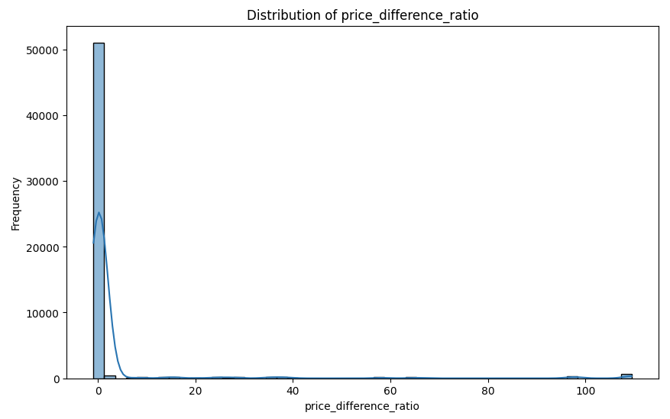
Figure 1a

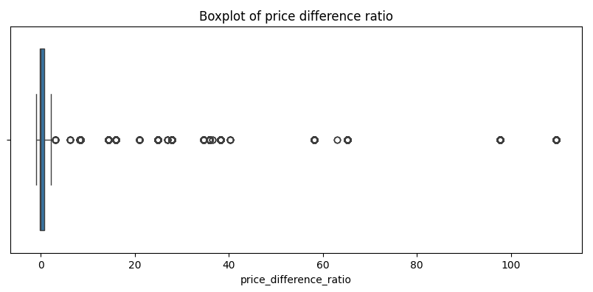
Figure 1b
The main problem with this particular dataset is the lack of labeled anomalies. Hence, the project should be based on unsupervised anomaly detection techniques rather than on supervised classification algorithms. Moreover, some characteristics associated with products were found to have some missing and imbalanced values.
Despite these limitations, there was enough transactional complexity to allow for modeling of the anomalies, as well as business context, to be able to identify anomalous behavior in sales and pricing, and inconsistencies in operations within the retail industry.

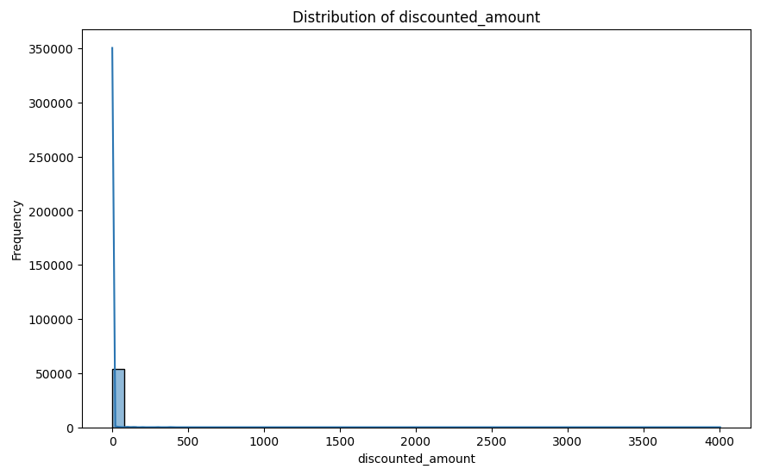
Figure 2a
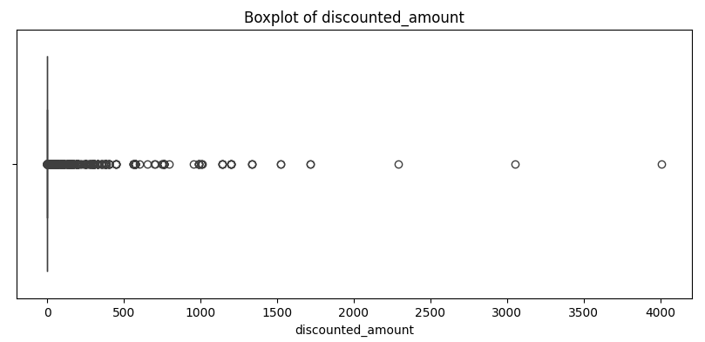
Figure 2b

Data Preparation
Several data preparation steps were performed before anomaly detection modelling to improve dataset quality, reduce redundancy, and prepare the data for machine learning.
Multiple transactional and product-related datasets were merged into a consolidated dataset containing sales orders, pricing, product attributes, and product classifications. The merged dataset initially contained 77,305 transaction-level observations and 49 raw features. After feature selection, feature engineering, and one-hot encoding, the final modelling datasets contained 75 transformed numerical features suitable for anomaly detection.
Data cleaning addressed missing values, redundant columns, inconsistent naming, and data type issues. Features with excessive missingness, such as discontinued_date and sell_end_date, were removed due to limited analytical value. Missing numerical values in variables such as weight and standard_cost were imputed using median values, while missing categorical variables were replaced with Unknown.
Highly correlated and constant variables, including is_sellable, were removed to improve modelling efficiency. Additional preprocessing included datetime conversion, one-hot encoding, and RobustScaler transformation for numerical variables due to substantial skewness and extreme outliers.
Many engineered features were created to improve anomaly detection capability. discounted_amount captured the monetary impact of discounts, while price_difference_ratio measured the relative difference between selling price and product cost. Additional variables such as order_month and weight_category captured seasonal purchasing behaviour and operational weight segments.
The dataset was split into training, validation, and testing subsets using a 70%-15%-15% strategy. This approach was appropriate for unsupervised anomaly detection because no target stratification was required. Separate validation and testing datasets supported stable evaluation and reduced overfitting risk.
Overall, the preparation process produced fully transformed datasets with no remaining missing values, making them suitable for Isolation Forest anomaly detection modelling.

Modeling
Two anomaly detection approaches were explored during the modelling phase: a baseline nearest-neighbour method and the final Isolation Forest model.
The baseline approach was initially used to identify unusual transactional behaviour through distance-based nearest-neighbour logic, where transactions with large deviations from surrounding observations were analysed as potential anomalies. However, due to the high dimensionality of the transformed dataset, substantial skewness, extreme outliers, and encoded categorical variables, this approach presented limitations related to distance sensitivity and scalability.
Consequently, Isolation Forest was selected as the final anomaly detection model because of its stronger robustness when handling large and complex retail datasets. Isolation Forest is an unsupervised algorithm that isolates anomalies through randomly generated decision trees, where observations isolated more quickly are considered more likely to be anomalous.
The model was chosen because it is computationally efficient, scalable, and robust to high-dimensional transactional data with skewed financial variables and rare behavioural patterns. Compared to distance-based methods, Isolation Forest performs more effectively when handling large numbers of transformed variables and complex feature structures.
Before training, numerical variables were scaled using RobustScaler to reduce the influence of extreme outliers while preserving anomaly-sensitive patterns. Categorical variables were transformed using one-hot encoding, and additional engineered features such as discounted_amount, price_difference_ratio, order_month, and weight_category were created to improve anomaly detection capability.
The final Isolation Forest model used a contamination parameter of 0.02, assuming that approximately 2% of transactions may represent unusual behaviour. Additional hyperparameters such as n_estimators=100 and random_state=42 were selected to improve model stability and reproducibility.
Overall, the modelling phase demonstrated that Isolation Forest provided a stable, scalable, and operationally practical solution for detecting anomalies within retail transactional data.

Evaluation

Evaluation Metrics
As the project applied unsupervised anomaly detection, traditional metrics such as accuracy, precision, recall, and F1-score were not used because the dataset did not contain labelled anomaly or fraud records. Instead, evaluation focused on anomaly consistency, model robustness across dataset splits, and business interpretation of detected anomalies.
One of the main evaluation measures was the percentage of anomalous transactions identified across the training, validation, and testing datasets. The anomaly proportions produced by the Isolation Forest model were compared across all splits to assess model stability and generalisation performance. Similar anomaly rates across unseen datasets were considered an important indicator of robustness.
Additional analysis examined the characteristics and distribution of detected anomalies, particularly for engineered financial features such as price_difference_ratio, discounted_amount, and sub_total. This helped determine whether the anomalies represented meaningful unusual transactional behaviour from a business perspective.
The selected evaluation approach aligned closely with the project objective, which focused on identifying rare and unusual transactional patterns rather than maximising classification accuracy against labelled outcomes.
From a business perspective, anomaly interpretability and operational usefulness were also important evaluation criteria. An effective anomaly detection model should identify a manageable number of unusual transactions while minimising excessive false positives that could create unnecessary operational workload.
Overall, the evaluation focused on model stability, anomaly consistency, and business relevance rather than traditional supervised learning performance metrics.

Results and Analysis
Traditional evaluation metrics such as accuracy, precision, recall, and F1-score could not be directly calculated because the project applied unsupervised anomaly detection and the dataset did not contain labelled anomalies. Therefore, evaluation focused on anomaly consistency, model stability across datasets, and business interpretation of detected anomalies.
Initially, a baseline anomaly detection approach based on nearest-neighbour and statistical distance concepts was explored to better understand unusual transactional behaviour. This preliminary analysis revealed substantial skewness, extreme outliers, and rare behavioural patterns across several financial and operational variables.
The final Isolation Forest model demonstrated stronger stability and scalability across the training, validation, and testing datasets. The model identified anomaly proportions of 2.00% in the training dataset, 2.12% in the validation dataset, and 1.79% in the testing dataset. The relatively consistent anomaly rates across all dataset splits suggest that the model generalised reasonably well to unseen data while avoiding excessive anomaly classifications.

Dataset | Anomaly percentage
Training | 2.00%
Validation | 2.12%
Testing | 1.79%
Figure 3

Several important insights were gained during experimentation. Engineered features such as price_difference_ratio, discounted_amount, and sub_total showed strong relevance for anomaly detection due to their high variability, strong skewness, and presence of extreme outliers.
The results indicate that Isolation Forest provided a more scalable and operationally practical solution than the baseline approach for detecting anomalies within retail transaction data. The model successfully identified rare and unusual observations while maintaining relatively stable anomaly behaviour across unseen datasets.
From a business perspective, the detected anomalies may support fraud investigation, operational monitoring, pricing validation, and transaction review processes. However, some detected anomalies corresponded to legitimate premium purchases or promotional activity rather than genuinely suspicious behaviour, highlighting the importance of business interpretation when evaluating anomaly detection outputs.
Potential areas for future improvement include additional hyperparameter tuning, incorporation of customer-level behavioural aggregation, experimentation with complementary anomaly detection algorithms, and operational validation of detected anomalies by business stakeholders.

Business Impact and Benefits
Isolation Forest modelling demonstrated the ability to identify a consistent set of rare transactions within large retail sales datasets. From a business perspective, this approach may improve operational monitoring by allowing organisations to focus only on transactions requiring further review instead of manually analysing all sales records.
One of the main advantages of the model is its ability to automatically detect unusual transaction patterns associated with abnormal pricing, extreme discounts, high transaction values, and operational inconsistencies. This capability may support fraud investigators, retail operations teams, and pricing specialists in identifying potentially suspicious activity more efficiently.
The model may also reduce operational workload by limiting the number of transactions requiring investigation. Based on the experimental results, approximately 2% of transactions were classified as potentially anomalous, allowing operational teams to focus on a relatively small subset of suspicious cases.
Additional business value may be generated through improved pricing control, stronger inventory management, and earlier identification of unusual customer purchasing behaviour or abnormal discount activity. The system may also help detect unexpected transactional patterns that could otherwise remain unnoticed within large retail datasets.
From a strategic perspective, the model provides a scalable and data-driven solution for monitoring complex retail transaction environments where manual anomaly detection becomes impractical. Furthermore, the unsupervised machine learning approach enables the detection of previously unknown anomaly patterns without requiring labelled fraud examples.
Although the absence of labelled anomaly data prevents direct estimation of financial savings, the relatively stable anomaly detection behaviour observed during experimentation suggests that the model has strong potential to improve operational monitoring and reduce financial risk exposure within a real-world retail environment.

Data Privacy and Ethical Concerns
The project analysed retail transaction data related to pricing, purchasing behaviour, and operations. Although the datasets did not contain personal identifiers or demographic information, privacy and ethical considerations remained important throughout the anomaly detection process.
The analysis focused on transactional patterns rather than individual profiling, and sensitive attributes such as race, religion, health, and financial details were not included. One key ethical concern was the risk of false-positive anomaly classifications, where legitimate transactions could be incorrectly flagged as suspicious. For this reason, the model was designed to support human review rather than fully automated decision-making.
The project also recognised that unsupervised models may unintentionally learn biases linked to geographic or operational patterns, potentially affecting Indigenous and other marginalised communities. To reduce these risks, the project incorporated careful preprocessing, feature selection, model interpretability, fairness monitoring, and human oversight before any real-world deployment.

Clustering (Abhiyan Gautam)

Business Understanding

Business Use Case
A global retailer manages a broad product catalogue across Bikes, Components, Clothing, and Accessories. This structure helps with inventory and reporting, but it is too broad for pricing decisions. The current problem is that products within the same category can be treated in the same way, even when they behave very differently in practice.
For example, one product may sell steadily without discounts, another may depend heavily on promotions, and another may carry high cost pressure despite strong sales. A category level view can hide these differences. This can lead to over discounting strong products, missing weak margin products, or applying the same pricing rule to products that need different commercial treatment.
This project uses clustering to replace broad category based thinking with data driven product segments. The model groups active products based on their actual pricing behaviour, cost structure, margin, discount exposure, sales volume, and product characteristics. This means products can be grouped by how they behave commercially, regardless of whether they belong to Bikes, Components, Clothing, or Accessories.
The business use case is product segmentation for pricing and discount governance. The output is actionable because each cluster maps to a clear commercial strategy. Pricing managers can use the segments to protect premium pricing, reduce discount frequency, review promotion dependent products, or improve cost efficiency for low margin high volume products.
Machine learning is relevant because clustering can find natural product groups across many commercial features at once. This gives the retailer a more detailed and practical view of product behaviour than the existing category structure.

Key Objectives
The main objective is to build a clear and usable segmentation model for commercially active products. The model must give stakeholders a practical view of product groups based on price, cost, margin, discount exposure, demand, and product characteristics.
- Create product segments that are commercially meaningful, not just statistically separated.
- Compare clustering algorithms against a simple K-Means baseline.
- Use validation and test sets to check whether the solution generalises beyond training data.
- Translate each final cluster into business actions for pricing, discounting, and product review.

The key stakeholders are the Pricing Team, Product Managers, and Commercial Director. The Pricing Team needs rules for discount governance. Product Managers need to understand which products are underperforming within their segment. The Commercial Director needs a simple portfolio view that highlights where intervention is needed first.

Data Understanding
The analysis uses product, product_sub_category, product_list_price_history, product_cost_history, special_offer, special_offer_product, and sales_order_detail data. The sales territory table operates at territory level, not product level: there's no meaningful way to aggregate territory-level sales behaviour into a single per-product feature without making unsupported assumptions. So, it was excluded. Together, these tables describe product attributes, price history, cost history, discounts, and sales volume. This is sufficient to build a clustering use case from the shared retail datasets.
The raw product table contains duplicate product_id rows. This issue was important because the first merged dataset created repeated products and caused data leakage across the training, validation, and test sets. The preparation stage fixed this by keeping one row per product_id before merging product-level features. After this correction, the final modelling population contains 172 unique active products. The split contains 120 training products, 26 validation products, and 26 test products, with zero product_id overlap across the three sets.
The final model uses 18 features after removing product_id from the modelling matrix. These features cover pricing level and stability, cost structure and stability, profitability, discount exposure, demand volume, product characteristics, and lifecycle status. The saved feature tables keep product_id only for traceability. It is removed before scaling, PCA, and clustering because it has no commercial meaning.
There is one clear limitation. The model only covers products with enough price and cost information to support clustering. Products without usable history are excluded, so cluster-based pricing recommendations should not be applied to uncovered products without further review.

Data Preparation
The preparation pipeline first aggregates each source table to product level. Price history is summarised into average list price, price volatility, and price change count. Cost history is summarised into average standard cost, cost volatility, and cost change count. Discount exposure is summarised through offer count, maximum discount percentage, and average discount percentage. Sales data is summarised as total units sold.
The product base was deduplicated before the joins. This was the most important cleaning step. Without it, the same product appeared multiple times in the model dataset, and the same product_id leaked across splits. After the fix, the final model_df contains 172 rows and 172 unique product_ids. Each split also has no duplicate product_id rows and no overlap with the other splits.
Missing values were handled based on business meaning. Products without average list price or average standard cost were removed because those values define the core commercial profile. Discount and sales fields were filled with zero where appropriate, because no linked discount or no recorded sale is meaningful. Categorical values such as product_line and class were encoded for modelling. Product_id was retained in saved files but removed before modelling, leaving 18 usable features.
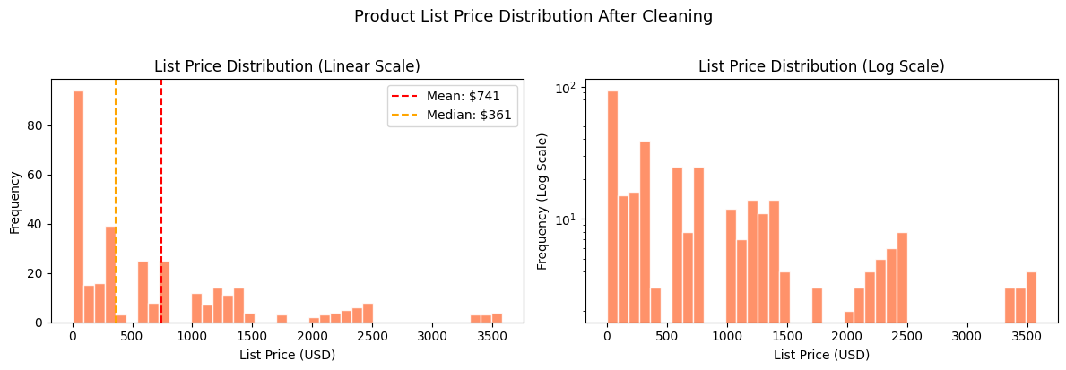
Figure 1. Product List Price Distribution on a Linear & Log Scale

Six skewed features were transformed using log1p: avg_list_price, avg_standard_cost, avg_margin, price_volatility, cost_volatility, and total_units_sold. This reduces the effect of extreme values while safely handling zero values. StandardScaler was then fitted only on the training set and applied to validation and test sets. That avoids leakage and keeps the evaluation realistic.
The final 70/15/15 split was stratified by product_category_id. This keeps the four product categories represented across training, validation, and test sets. The result is 120 training products, 26 validation products, and 26 test products.

Modeling
The baseline model used K-Means with k=4 on the 18 scaled features. The choice of k=4 mirrors the four existing product categories. This creates a simple benchmark: a better clustering model should beat the existing category-style structure while still producing interpretable product groups.

Table 1. Baseline K-Means k=4 performance
Metric | Train | Validation
Silhouette | 0.3216 | 0.3099
Davies-Bouldin | 1.1935 | 1.1211
Calinski-Harabasz | 44.47 | 13.80
ARI | 0.1590 | 0.1044
NMI | 0.3321 | 0.3423

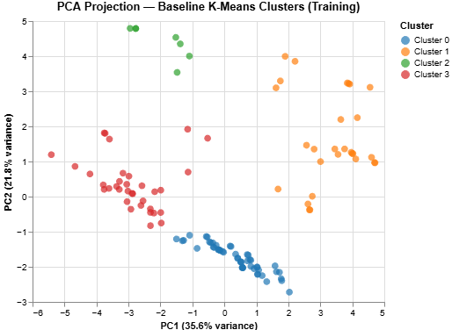
Figure 2. PCA Project of the Baseline K-means Clusters (k=4)

The final modelling stage tested three candidates: K-Means with PCA, DBSCAN, and Agglomerative Hierarchical clustering with Ward linkage. PCA reduced the 18-feature space to five components while retaining 85.4% of total variance. PC1 captured the price, cost, and margin axis. PC2 captured discount exposure and sales volume. This helped reduce redundant feature overlap before clustering.
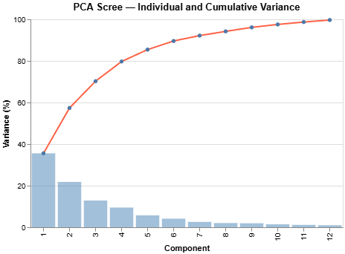
Figure 3. PCA Scree Plot (Training Set)

K-Means was tuned from k=2 to k=10 using silhouette analysis. The best training result occurred at k=5, with a silhouette score of 0.4312. On validation, K-Means k=5 achieved a silhouette score of 0.4497, a Davies-Bouldin Index of 0.7347, and a Calinski-Harabasz Index of 20.00. These results beat the baseline on the main internal metrics.
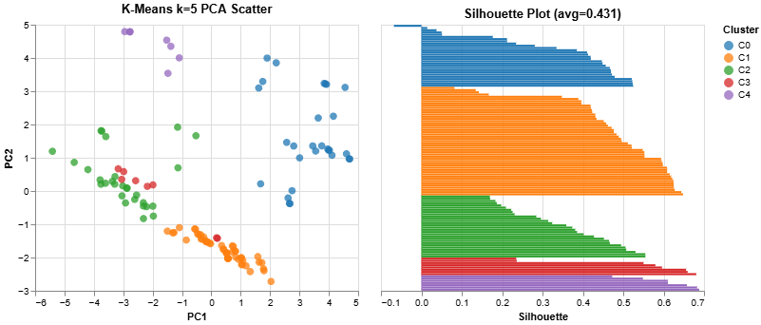
Figure 4. K-Means k=5 PCA Scatter & Silhouette Plots

DBSCAN produced a strong training silhouette of 0.4835 on non-noise products, but it labelled 40 of 120 training products as noise. It also failed to produce valid validation metrics because the validation set had too few valid clusters. That makes DBSCAN unsuitable for this business use case. A pricing segmentation system needs every product to receive a usable segment.
Agglomerative clustering with k=5 produced the same validation results as K-Means k=5 when validation products were assigned using a NearestCentroid approximation. Since K-Means gives direct centroids and a simpler prediction rule for new products, it was selected as the final model.

Table 2. Candidate model comparison on validation data.
Metric | Baseline Val | K-Means k=5 Val | Agglom. k=5 Val
Silhouette | 0.3099 | 0.4497 | 0.4497
Davies-Bouldin | 1.1211 | 0.7347 | 0.7347
Calinski-Harabasz | 13.80 | 20.00 | 20.00
ARI | 0.1044 | 0.1133 | 0.1133
NMI | 0.3423 | 0.3464 | 0.3464

Evaluation

Evaluation Metrics
The main evaluation metrics are Silhouette Score, Davies-Bouldin Index, and Calinski-Harabasz Index. Silhouette measures how well each product fits inside its own cluster compared with nearby clusters. Higher is better. Davies-Bouldin measures how compact and separated the clusters are. Lower is better. Calinski-Harabasz compares between-cluster separation with within-cluster compactness. Higher is better.
ARI and NMI are used as secondary checks against product_category_id. They are not the main optimization target because the goal is not to recreate the existing four-category taxonomy. The goal is to find commercial segments that may cross those category boundaries.

Results and Analysis
K-Means k=5 is the best final model. Its validation silhouette of 0.4497 improves on the baseline value of 0.3099 by about 45%. Davies-Bouldin drops from 1.1211 to 0.7347, showing stronger separation and tighter clusters. Calinski-Harabasz rises from 13.80 to 20.00, which supports the same conclusion.
The small train-to-validation gap is a positive result. Training silhouette is 0.4312 and validation silhouette is 0.4497. This suggests the model is not simply fitting noise in the training set. The validation result is slightly stronger, which can happen when the validation sample contains clearer examples of the same cluster structure.
The five clusters have clear business profiles:

Cluster | Segment Name | n | Commercial Profile | Priority Action
C0 | Premium Manufactured | 28 | High price, cost, margin (+0.9σ); above-avg lead times; near-zero discounts; below-avg sales | Strict no-discount policy; protect margin
C1 | Mid-Tier Complex | 49 | Moderate price/margin (+0.4σ); longest manufacture time; lowest discount exposure; below-avg sales | Investigate volume gap; build lead time into pricing
C2 | Budget Standard | 28 | Below-avg price/margin/cost (−0.3σ); fast production; minimal promotions; moderate steady sales | Maintain price competitiveness; leverage production efficiency
C3 | Consistently Promoted, High-Volume | 8 | Near-avg price; avg_discount_pct at +3σ; highest units sold; promotion structurally embedded | Test price elasticity; trial reduced promotional coverage
C4 | High-Velocity, Low-Margin | 7 | Below-avg price; fastest production (−1.0σ); above-avg sales (+1.1σ); below-avg margin% | Supply chain cost efficiency; volume-based margin recovery

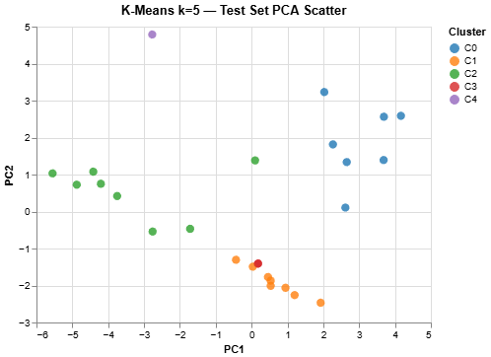
Figure 5. Final K-Means k=5 cluster assignments plotted on test set

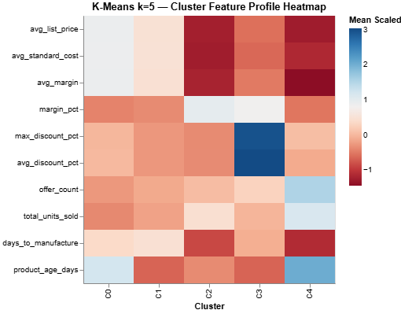
Figure 6. Cluster profile heatmap for key pricing, cost, margin, discount, and demand features.

Business Impact and Benefits
The final segmentation gives the business a more useful pricing layer than the existing product taxonomy. Four of the five clusters cut across product categories, which shows that commercial behaviour does not always follow catalogue structure. This is the main value of the model.
For Cluster 0, the business should protect price and avoid discounting. For Cluster 1, the priority is investigating whether long manufacturing time is limiting sales. For Cluster 2, the goal is to preserve efficient low-price positioning. Cluster 3 needs immediate discount review because high sales appear closely tied to promotion. Cluster 4 needs margin recovery through cost control because price increases could damage its high-volume position.
The model supports quarterly commercial reviews. It gives the Pricing Team a rule-based way to govern discounts, gives Product Managers clearer product-level signals, and gives the Commercial Director a portfolio view of where action is needed. The most urgent focus should be Cluster 3 and Cluster 4 because they carry the clearest margin and discount risks.

Data Privacy and Ethical Concerns
The privacy risk for this component is low. The model uses product-level data only and does not incorporate customer names, personal identifiers, addresses, or transaction-level customer profiles. Product_id is retained solely for traceability and is excluded before modelling begins.
The primary ethical risk is commercial misuse. A product could be incorrectly targeted for discount cuts or discontinuation if decision-makers treat cluster membership as a definitive answer rather than a decision-support signal. This risk is greatest for small clusters, particularly Cluster 3 and Cluster 4, which contain only 8 and 7 products respectively. Human review should remain mandatory before any major pricing, discount, or discontinuation decision is made on the basis of cluster assignment alone.
In the Australian context, there is also an equity consideration. Commercial decisions informed by this model, such as price increases or product discontinuation, can affect affordability for price-sensitive customers. Aboriginal and Torres Strait Islander communities face documented socioeconomic disadvantage in Australia and may rely more heavily on budget-accessible products. Cluster 2 and Cluster 4 in particular represent lower-price, high-efficiency products that serve as accessible entry points. Removing or significantly repricing these products based solely on cluster membership, without considering who depends on them, risks compounding existing inequity.
A coverage limitation also applies. The model represents only the 172 active products with complete price and cost histories. Products outside this modelling population should not receive cluster-based pricing rules automatically. Any dashboard built on this model should clearly distinguish which products fall within the clustering pipeline and which sit outside its scope.

Collaboration

Individual Contributions
Erkebai Bakhavadinov was responsible for the classification component focused on predicting customer repeat-purchase behaviour at AdventureWorks. He conducted exploratory data analysis, feature engineering, and model development using Logistic Regression, Random Forest, and Gradient Boosting, selecting Random Forest as the final model. He also contributed to business impact analysis and ethical considerations, including fairness and risks for Indigenous customers.
Vedang Gosavi was responsible for the regression and revenue forecasting components of the project. He conducted exploratory data analysis, preprocessing, feature engineering, and implemented Linear Regression, Ridge Regression, and Random Forest Regression models, selecting Random Forest as the final model. He also contributed to model evaluation, business impact analysis, and ethical considerations related to predictive analytics.
Rose Marie Tazbaz was responsible for the anomaly detection component of the project, including data preparation, feature engineering, modelling, evaluation, and business interpretation. She conducted exploratory data analysis, preprocessing, feature selection, and engineered anomaly-sensitive features such as discounted_amount and price_difference_ratio. She selected Isolation Forest as the final model and also contributed to ethical analysis and CRISP-DM project documentation.
- Describe the individual contributions of each team member.
- Explain the specific tasks, responsibilities, or areas of expertise assigned to each team member.
- Highlight any significant contributions or achievements made by individual team members.
Abhiyan Gautam was responsible for the clustering component of the project, focused on discovering natural commercial groupings among products in the AdventureWorks catalogue. He handled data preparation, feature engineering, and preprocessing, building a clean modelling dataset from the raw product catalogue. He developed and evaluated multiple clustering approaches including K-Means, DBSCAN, and Agglomerative Hierarchical clustering, selecting K-Means as the final model. He also contributed to business interpretation by profiling each discovered segment with actionable commercial recommendations, and provided analysis of how the data-driven segmentation compares to the organisation's existing product taxonomy.

Group Dynamic
The group maintained a collaborative and well-coordinated workflow throughout the project. Initial meetings were used to review requirements, discuss expectations, and allocate responsibilities across project sections.
During development, the team held regular progress discussions to address technical challenges and maintain consistency across project components. Most communication occurred through WhatsApp, supporting efficient coordination, troubleshooting, and progress tracking.
Although tasks were completed independently, team members consistently supported one another through collaborative problem-solving, output reviews, and technical assistance, helping maintain steady progress toward the final submission.

Ways of Working Together
The team adopted a collaborative and flexible workflow throughout the project, using regular Google Meet sessions and WhatsApp coordination to review progress, solve technical issues, and plan next steps.
Tasks were distributed according to each member’s strengths across data preparation, modelling, evaluation, and reporting. Collaboration was supported through Google Meet, WhatsApp, Google Drive, Jupyter Notebook, and Google Colab.
Some challenges included coordinating schedules and maintaining consistency across dataset versions, but continuous communication helped the team manage these issues effectively.

Issues Faced
The team faced challenges related to time management, coordination, and technical issues within Google Colab and Jupyter Notebook, including occasional debugging of execution and package-related errors.
Coordinating meetings was sometimes difficult due to varying academic schedules and workloads, particularly near the submission deadline. However, all team members remained actively involved and completed their responsibilities responsibly.
These challenges were managed through regular communication, Google Meet discussions, WhatsApp coordination, and collaborative problem-solving. A key lesson learned was the importance of early task allocation, consistent communication, and regular progress tracking in collaborative machine learning projects.

Conclusion
This project demonstrated how machine learning algorithms can address multiple business problems within the retail environment, including customer classification, sales revenue prediction, anomaly detection, and customer segmentation. Across all models, business understanding, exploratory data analysis, feature engineering, and machine learning techniques were successfully integrated using retail transactional data.
The classification model showed that customer repeat-purchase behaviour can be predicted effectively using transactional features, while the regression model demonstrated strong capability for forecasting transaction-level revenue to support budgeting and pricing decisions. The anomaly detection component also showed that unsupervised models such as Isolation Forest can successfully identify unusual transactional behaviour without labelled fraud data.
One of the main insights gained throughout the project was the importance of data preparation and business understanding in determining model performance. Feature engineering, handling missing values, managing outliers, and understanding dataset limitations proved to be as important as the modelling process itself.
Overall, the project achieved its main objectives by demonstrating that machine learning algorithms can generate meaningful business value across several retail applications. At the same time, opportunities for improvement remain, including temporal model evaluation, additional feature engineering, segment-based modelling approaches, fairness monitoring, and deployment of the final solutions.
Future work should focus on improving model robustness and production readiness through automated model monitoring, periodic evaluation for model drift, incorporation of additional behavioural and transactional features, and A/B testing to measure direct business impact.

References
- Include a list of references used throughout the project report.
Instructions: Include a list of references used throughout the project report, following the appropriate citation style.
Aggarwal, C. C. (2017). Outlier Analysis (2nd ed.). Springer International Publishing.
Carroll, S. R., Garba, I., Figueroa-Rodríguez, O. L., Holbrook, J., Lovett, R., Materechera, S., Parsons, M., Raseroka, K., Rodriguez-Lonebear, D., Rowe, R., Sara, R., Walker, J. D., Anderson, J., & Hudson, M. (2020). The CARE principles for Indigenous data governance. Data Science Journal, 19(1), Article 43.
Liu, F. T., Ting, K. M., & Zhou, Z. H. (2008). Isolation forest. Proceedings of the 2008 Eighth IEEE International Conference on Data Mining, 413–422.
Microsoft Corporation. (2022). AdventureWorks sample databases. Microsoft Docs.
Breiman, L. (2001). Random forests. Machine Learning, 45(1), 5–32. https://doi.org/10.1023/A:1010933404324
James, G., Witten, D., Hastie, T., & Tibshirani, R. (2021). An introduction to statistical learning: With applications in R (2nd ed.). Springer.
Kuhn, M., & Johnson, K. (2019). Feature engineering and selection: A practical approach for predictive models. CRC Press.
Jobin, A., Ienca, M., & Vayena, E. (2019). The global landscape of AI ethics guidelines. Nature Machine Intelligence, 1(9), 389–399.
Jain, A. K., Murty, M. N., & Flynn, P. J. (1999). Data clustering: A review. ACM Computing Surveys, 31(3), 264-323. https://doi.org/10.1145/331499.331504
Kaufman, L., & Rousseeuw, P. J. (1990). Finding groups in data: An introduction to cluster analysis. Wiley.
Rousseeuw, P. J. (1987). Silhouettes: A graphical aid to the interpretation and validation of cluster analysis. Journal of Computational and Applied Mathematics, 20, 53-65. https://doi.org/10.1016/0377-0427(87)90125-7

